# Apply filters to SQL queries

## Project description

In this project, the example organization is reviewing security issues from employees and log-in attempts using SQL to retrieve the data. The following are my SQL queries that were used to filter the data.

## Retrieve after hours failed login attempts

This query began by selecting all, then focusing in on the log_in_attempts table. I then filtered the table to after 18:00, or 6:00 pm to gain access to the after hours login attempts. I also filtered out the successful login attempts by assuming that the success variable was set to 0, or False, as my focus was the attempts that failed.

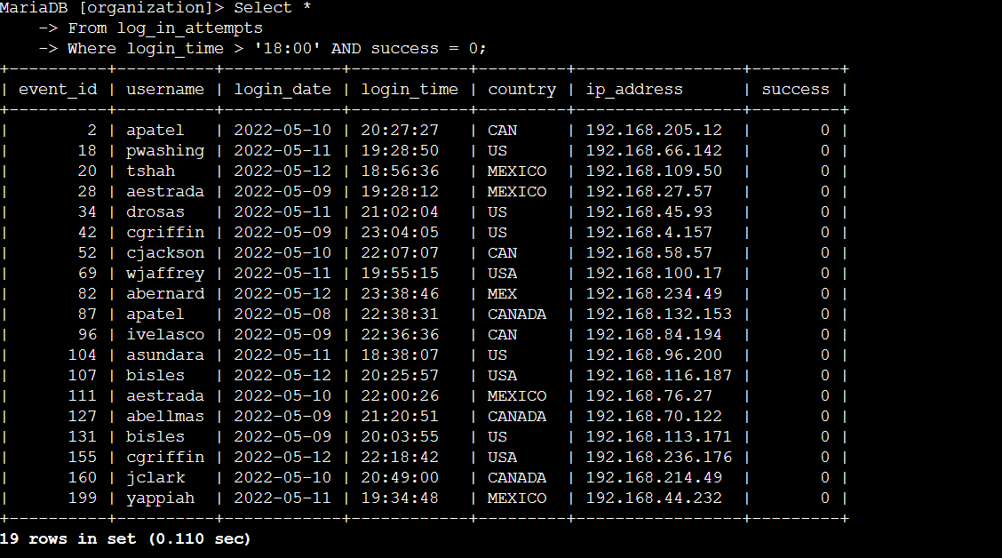

## Retrieve login attempts on specific dates

My next query also was table to the log_in_attempts table. This query, however, filtered out all log_in_attempts not on May 8th or 9th, as the date under investigation was the 9th. I used the OR operator and filtered for login attempts which date variable matched either date.

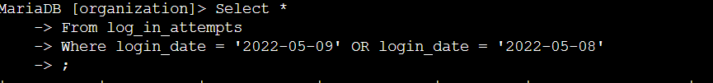

## Retrieve login attempts outside of Mexico

Finally, my last log_in_attempts query was to filter out and return login attempts not made from Mexico. Since Mexico was recorded as MEX and MEXICO, I used the like function to filter in all countries that started with MEX. I also used the NOT operator to filter out Mexico instead of filtering it in.



## Retrieve employees in Marketing

This query returned data from the employees table, using the AND operator to only return employees who had Marketing in their department column and in their office column had a string that started with East in order to only return those in an East building.

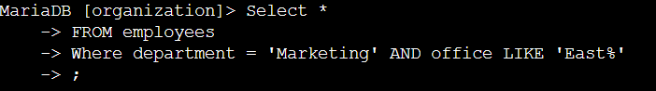

## Retrieve employees in Finance or Sales

My next query used the OR operator in the employees table to make sure that the employees returned had either sales or finance in their department column.



## Retrieve all employees not in IT

Finally, my last query in the employees table used the NOT operator to return all employees that did not have Information Technology in their department column.

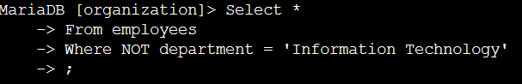

## Summary

I used a filtered query in SQL to return specific data on employees and login attempts that matched my criteria. I did so by using a few boolean operators and functions like AND, LIKE, NOT, and OR.